**Building a Docker file and to start a Server**

1. To open the editor

vim Dockerfile

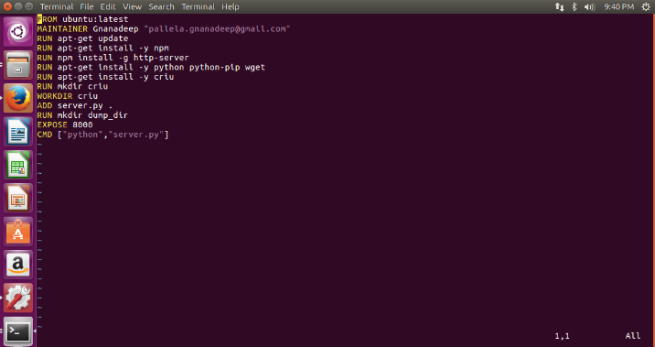

1. To build the image

docker build .

1. To get the IMAGE_ID

docker images

1. To create a container to run the server

docker run -p 127.0.0.1:80:8000 -t Image_id

Serving HTTP on 0.0.0.0 port 8000 ...

